

**REPORT FOR SOCIAL NETWORKING SITE CREATED USING HTML & CSS**

***DETAILS OF FIRST MEMBER:***

***NAME: AMAN KUMAR***

***REGISTRATION NUMBER: 12106661***

***ROLL NUMBER: RK21GPB58***

***PROGRAM: B.TECH ( COMPUTER SCIENCE AND ENGINEERING )***

***SCHOOL: SCHOOL OF COMPUTER SCIENCE AND ENGINEERING***

***NAME OF UNIVERSITY: LOVELY PROFESSIONAL UNIVERSITY***

***DATE OF SUBMISSION: 15th APRIL 2022***

***DETAILS OF SECOND MEMBER:***

***NAME: HIMANSHU SHARMA***

***REGISTRATION NUMBER: 12107151***

***ROLL NUMBER: RK21GPB96***

***PROGRAM: B.TECH ( COMPUTER SCIENCE AND ENGINEERING )***

***SCHOOL: SCHOOL OF COMPUTER SCIENCE AND ENGINEERING***

***NAME OF UNIVERSITY: LOVELY PROFESSIONAL UNIVERSITY***

***DATE OF SUBMISSION: 15th APRIL 2022***

**TABLE OF CONTENTS**

|  |  |  |
| --- | --- | --- |
| **S.NO** | **CONTENTS** | **PAGE NO’S** |
| **1** | **Abstract** | **3** |
| **2** | **Introduction** | **4-5** |
| **3** | **Objective** | **6-24** |
| **4** | **GitHub Links** | **25** |

**ABSTARCT**

**Social networks, which have almost become part of our daily lives, have established new communication structures and behaviors in society. While citizens and businesses have already extensively used social networks for years, governments continuously increase their interest in the new communication technologies. Sites such as Facebook, Twitter, and Linked In provide a mechanism for individuals to come together based on a variety of factors such as existing friendships, common interests, or work. People have discovered how the use of social networks can facilitate communication and the exchange/sharing of thoughts and ideas.**

**A social network service focuses on the building and verifying of online social networks for communities of people who share same interests and activities, or who are interested in exploring the interests and activities of others, and which necessitates the use of software or a full fledged website. Most services are primarily web based and provide a collection of various ways for users to interact, such as messaging, queries, advices and file uploading.**

**Social networking sites are increasingly deployed, albeit unintentionally, not only as a platform for computer-mediated communication but also as a substitute for face-to-face forms of social interaction. Social networking sites interactions are characterized by an ease and immediacy, often nonreplicable in the offline world. Unfettered by the constraints of physical proximity, geographical setting, or time zone. Social networking sites allow for mobile, instant, and continuous exchange.**

**INTRODUCTION**

**In this report we will explain and display the functioning and basic structure of our website named 5AM Club .**

* **What is a social networking website ?**

**A social networking service or SNS (sometimes called social networking site) is an online platform which people use to build social networks or social relationships with other people who share similar personal or career content, interests, activities, backgrounds or real-life connections**

**Social networking services vary in format and the number of features. They can incorporate a range of new information and communication tools, operating on desktops and on laptops, on mobile devices such as tablet computers and smartphones. This may feature digital photo/video/sharing. Online community services are sometimes considered social-network services by developers and users, though in a broader sense, a social-network service usually provides an individual-centered service whereas online community services are groups centered. Generally defined as "websites that facilitate the building of a network of contacts in order to exchange various types of content online," social networking sites provide a space for interaction to continue beyond in-person interactions. These computer mediated interactions link members of various networks and may help to create, sustain and develop new social and professional relationships.**



* **Why do we use SNS ?**

**1. To stay in touch with what friends are doing**

**2. To stay up-to-date with news and current events**

**3. To fill up spare time**

**4. To find funny or entertaining content**

**5. General networking with other people**

**6. Because friends are already on them**

**7. To share photos or videos with others**

**8. To share my opinion**

**9. To research new products to buy**

**10. To meet new people**

* **Types of SNS**

1. **Social Networks: Facebook, Twitter, LinkedIn**
2. **Media Sharing Networks: Instagram, Snapchat, YouTube**
3. **Discussion Forums: Reddit, Quora, Digg**
4. **Bookmarking & Content Curation Networks: Pinterest, Flipboard**
5. **Consumer Review Networks: Yelp, Zomato, TripAdvisor**
6. **Blogging & Publishing Networks: WordPress, Tumblr, Medium**



**Objective**

**The main objective of our project on social networking website**

**(5AM Club) is to manage all the information of the user ( Name , Phone number or email , Password , DOB ) when he/she creates his/her account on the website.**

**This website is developed for people having age greater than 14.**

**The project is totally built at administrative end and thus only the administrator/developer is granted the access to change anything like changing layout and other things.**

**We are ready to serve you differently. A new world is rising. Let’s discover it. Our website helps sharing of ideas, information, messages, and other forms of content amongst people.**

**All thanks to 5AM Club, we are connected and stay connected and keep updated on the lives of the people we know, or even the people we want to know about.**

**Through 5AM, a single post can get viral and reach hundreds and thousands of people at the same time through their phones, all at the same time. A single video, having the right kind of content can easily cross a million views. In this 21st Century, SNS plays an important role in defining the success or the failure of a business. That is how crucial Social Media content is!**



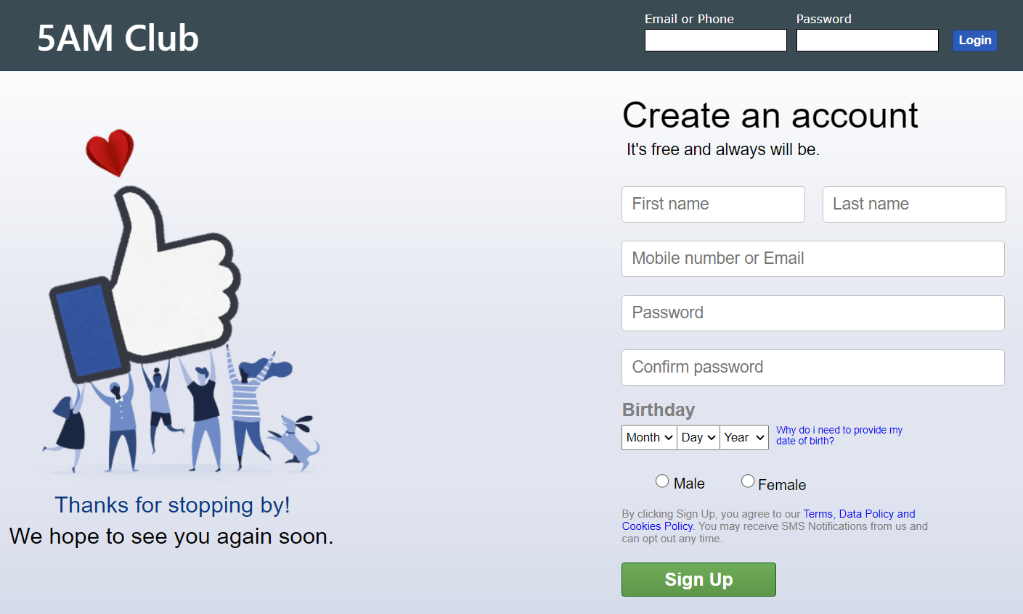

**Our website's name is 5AM Club. This is the login page/first page which will be displayed on the user’s display.**

**Here the user will provide his/her details such as First name, Last name, Mobile number or email, Password and then confirming it, Date of birth, Gender and then logging into his/her account.**

**We have designed our login page in such a manner that every user will be able to open his/her account easily without any difficulty.**

**Terms, Data Policy is also given so that user can see how his/her data is being used and shared within different websites with the help of cookies.**

**Code for sign-up body**

<div *class*="signup_body">

            <p *class*="acc_crt">Create an account</p>

            <p *class*="free_hint">It's free and always will be.</p>

            <form *class*="signup_form" *action*="{{ url_for('signup') }}" *method*="POST">

                <div>

                    <input *class*="firstname" *type*="text" *name*="first_name" *placeholder*="First name" *required*>

                    <input *class*="lastname" *type*="text" *name*="last_name" *placeholder*="Last name" *required*>

                    <input *class*="email" *type*="text" *name*="username" *placeholder*="Mobile number or Email" *required*>

                    <input *class*="password" *type*="password" *name*="password" *placeholder*="Password" *id*="pass" *required*>

                    <input *class*="password2" *type*="password" *name*="password" *placeholder*="Confirm password" *id*="confirmpass" *required*>

                    <p *id*="error" *style*="color: red;"></p>

                </div>



**Resources Used**

* **HTML**
* **CSS**
* **JS**
* **SQL**
* **PYTHON**

**Main Feed/Website**

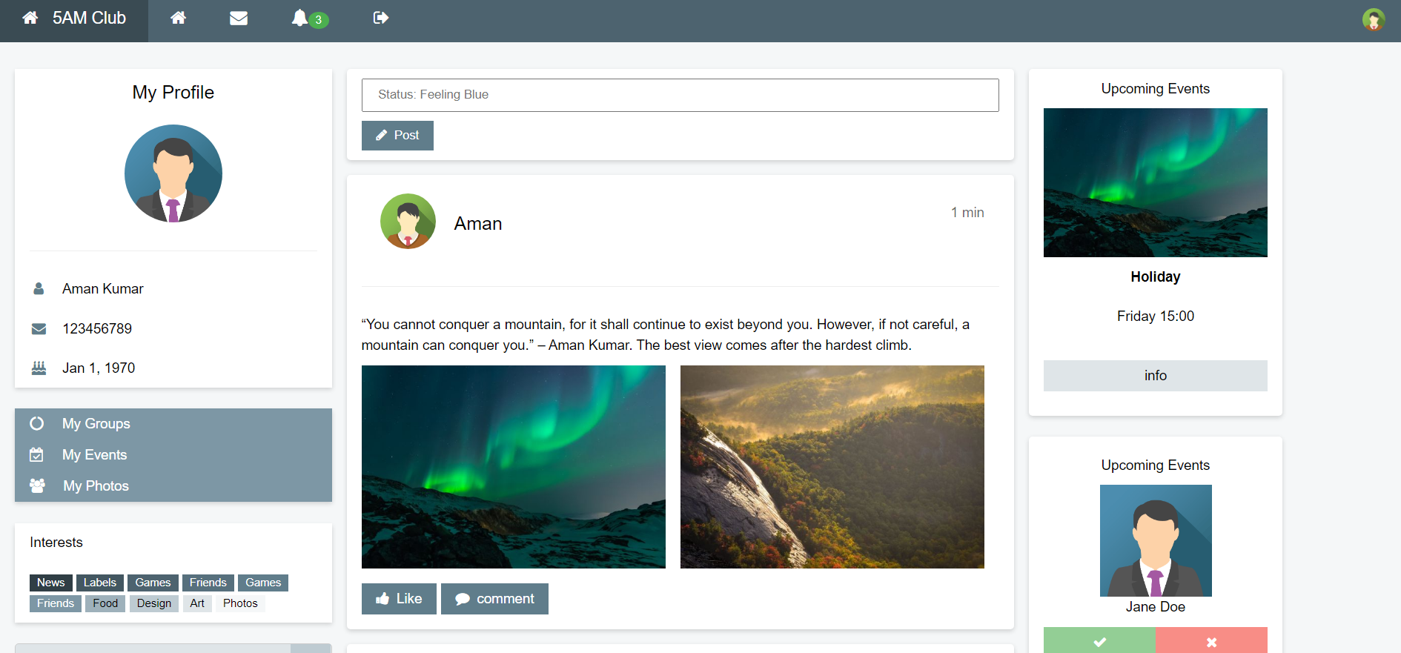

**This is the main feed page of our website. Here we have displayed**

**everything which a user will require on priority basis.**

* **On top left corner the user details are displayed.**
* **Code for Details section:-**

<div *class*="container">

        <div *class*="row">

            <section *class*="firstColumn">

                <div *class*="card">

                    <div *class*="container1">

                        <h4>My Profile</h4>

                        <p *class*="mainPic"><img *src*="{{ url_for('static' , filename='assets/photo2.png') }}"></p>

                        <hr>

                        <p><i *class*="fa fa-user fa-fw"></i>{{first_name}} {{ last_name }}</p>

                        <p><i *class*="fa fa-envelope fa-fw"></i>{{username}}</p>

                        <p><i *class*="fa fa-birthday-cake fa-fw"></i>{{dob}}</p>

                    </div>

                </div><br>

* **Below details section we have displayed the interests of the current user and below it the activity which is being done on user’s account is displayed**

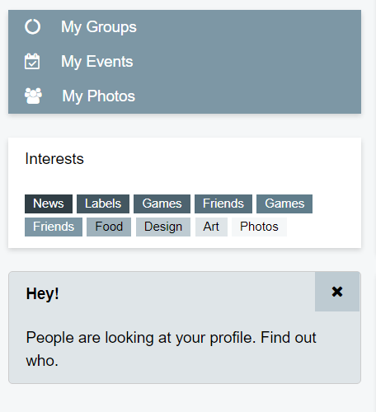



* **Code for this section is:-**

<div *class*="card1">

                        <button *onclick*="myfunction('demo1')">

                            <i *class*="fa fa-circle-o-notch"></i> My Groups

                        </button>

                        <div *id*="demo1"><p>Groups</p></div>

                        <button *onclick*="myfunction1('demo2')">

                            <i *class*="fa fa-calendar-check-o"></i> My Events

                        </button>

                        <div *id*="demo2"><p>Events</p></div>

                        <button *onclick*="myfunction2('demo3')">

                            <i *class*="fa fa-users"></i> My Photos

                        </button>

                        <div *id*="demo3">

                            <div *class*="row1">

                                <div *class*="photoHalf">

                                    <div *class*="half"><img *src*="{{ url_for('static' , filename='assets/photo3.png') }}"></div>

                                    <div *class*="half"><img *src*="{{ url_for('static' , filename='assets/photo3.png') }}"></div>

                                    <div *class*="half"><img *src*="{{ url_for('static' , filename='assets/photo3.png') }}"></div>

                                </div>

                                <div *class*="photoHalf">

                                    <div *class*="half"><img *src*="{{ url_for('static' , filename='assets/photo3.png') }}"></div>

                                    <div *class*="half"><img *src*="{{ url_for('static' , filename='assets/photo3.png') }}"></div>

                                    <div *class*="half"><img *src*="{{ url_for('static' , filename='assets/photo3.png') }}"></div>

                                </div>

                            </div>

                        </div>

                </div><br>

                <div *class*="card2">

                    <div *class*="container1">

                        <p>Interests</p>

                        <p>

                            <span *class*="bg1Card2 card2white">News</span>

                            <span *class*="bg3Card2 card2white">Labels</span>

                            <span *class*="bg4Card2 card2white">Games</span>

                            <span *class*="bg5Card2 card2white">Friends</span>

                            <span *class*="bg6Card2 card2white">Games</span>

                            <span *class*="bg7Card2 card2white">Friends</span>

                            <span *class*="bg8Card2 card2black">Food</span>

                            <span *class*="bg9Card2 card2black">Design</span>

                            <span *class*="bg10Card2 card2black">Art</span>

                            <span *class*="bg11Card2 card2black">Photos</span>

                        </p>

                    </div>

                </div><br>

                <div *class*="card3">

                    <div *class*="container1">

                        <span *onclick*="removebtn()"><i *class*="fa fa-remove"></i></span>

                        <p><strong>Hey!</strong></p>

                        <p>People are looking at your profile. Find out who.</p>

                    </div>

                </div>

* **In center , user’s posts are displayed along with his/her status at the top.**

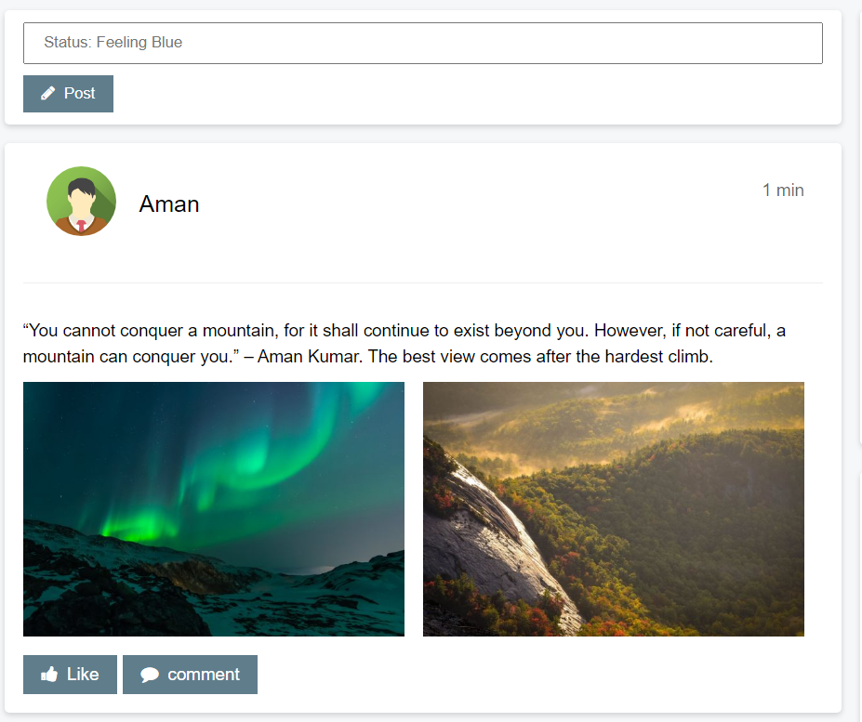

* **Code for this section is:-**

<section *class*="midColumn">

                <div *class*="post">

                    <div *class*="container1">

                        <p><input *type*="text" *name*="" *placeholder*="Status: Feeling Blue"></p>

                        <button *type*="button"><i *class*="fa fa-pencil"></i>Post</button>

                    </div>

                </div>

                <div *class*="userFirst">

                    <div *class*="container1">

                        <img *class*="miduserpic" *src*="{{ url_for('static' , filename='assets/photo1.png') }}">

                        <h4>{{first_name}}</h4>

                        <span>1 min</span>

                        <div *class*="clearfix"></div><hr>

                        <p>“You cannot conquer a mountain, for it shall continue to exist beyond you. However, if not careful, a mountain can conquer you.” – {{ first_name }} {{ last_name }}. The best view comes after the hardest climb.</p>

                        <div *class*="userGallery">

                            <div *class*="userHalf"><img *src*="{{ url_for('static' , filename='assets/photo3.png') }}"></div>

                            <div *class*="userHalf"><img *src*="{{ url_for('static' , filename='assets/photo4.png') }}"></div>

                        </div>

                        <button *type*="button"><i *class*="fa fa-thumbs-up"></i>Like</button>

                        <button *type*="button"><i *class*="fa fa-comment"></i>comment</button>

                    </div>

                </div>

                <div *class*="userFirst">

                    <div *class*="container1">

                        <img *class*="miduserpic" *src*="{{ url_for('static' , filename='assets/photo1.png') }}">

                        <h4>{{first_name}}</h4>

                        <span>16 min</span>

                        <div *class*="clearfix"></div><hr>

                        <p>“Just take my hand, lead, dance with me...and I will simply follow the blueness of the water, the white waves rolling free...where the earth beneath my feet and stars make my heart whole again...in long and priceless moments of shared solitude...” - {{ first_name }} {{ last_name }}</p>

                        <button *type*="button"><i *class*="fa fa-thumbs-up"></i>Like</button>

                        <button *type*="button"><i *class*="fa fa-comment"></i>comment</button>

                    </div>

                </div>

                <div *class*="userFirst">

                    <div *class*="container1">

                        <img *class*="miduserpic" *src*="{{ url_for('static' , filename='assets/photo1.png') }}">

                        <h4>{{first_name}}</h4>

                        <span>32 min</span>

                        <div *class*="clearfix"></div><hr>

                        <p>Have you seen this?</p>

                        <div *class*="userImage"><img *src*="{{ url_for('static' , filename='assets/photo3.png') }}"></div>

                        <p>"When one door closes, another opens; but we often look so long and so regretfully upon the closed door that we do not see the one which has opened for us" - {{ first_name }} {{ last_name }}</p>

                        <button *type*="button"><i *class*="fa fa-thumbs-up"></i>Like</button>

                        <button *type*="button"><i *class*="fa fa-comment"></i>comment</button>

                    </div>

                </div>

            </section>

*<!-- /End secondcolumn -->*

            <section *class*="thirdColumn">

                <div *class*="rightCard">

                    <div *class*="container1">

                        <p>Upcoming Events</p>

                        <img *src*="{{ url_for('static' , filename='assets/photo3.png') }}">

                        <p><strong>Holiday</strong></p>

                        <p>Friday 15:00</p>

                        <p><button *type*="button">info</button></p>

                    </div>

                </div><br>

                <div *class*="rightCard1">

                    <div *class*="container1">

                        <p>Upcoming Events</p>

                        <img *src*="{{ url_for('static' , filename='assets/photo2.png') }}"><br>

                        <span>Jane Doe</span>

                        <div *class*="fullbtn">

                            <div *class*="btnHalf"><button *class*="green" *type*="button"><i *class*="fa fa-check"></i></button></div>

                            <div *class*="btnHalf"><button *class*="orange" *type*="button"><i *class*="fa fa-remove"></i></button></div>

                        </div>

                    </div>

                </div><br>

                <div *class*="bug"><p><i *class*="fa fa-bug"></i></p></div>

            </section>

        </div>

    </div>

* **On the right hand side we have displayed upcoming events and current friend request**

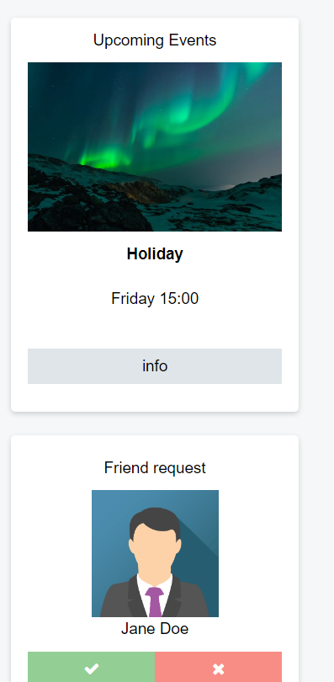

* **Code for this section is:-**

<section *class*="thirdColumn">

                <div *class*="rightCard">

                    <div *class*="container1">

                        <p>Upcoming Events</p>

                        <img *src*="{{ url_for('static' , filename='assets/photo3.png') }}">

                        <p><strong>Holiday</strong></p>

                        <p>Friday 15:00</p>

                        <p><button *type*="button">info</button></p>

                    </div>

                </div><br>

                <div *class*="rightCard1">

                    <div *class*="container1">

                        <p>Friend request</p>

                        <img *src*="{{ url_for('static' , filename='assets/photo2.png') }}"><br>

                        <span>Jane Doe</span>

                        <div *class*="fullbtn">

                            <div *class*="btnHalf"><button *class*="green" *type*="button"><i *class*="fa fa-check"></i></button></div>

                            <div *class*="btnHalf"><button *class*="orange" *type*="button"><i *class*="fa fa-remove"></i></button></div>

                        </div>

                    </div>

                </div><br>

                <div *class*="bug"><p><i *class*="fa fa-bug"></i></p></div>

            </section>

        </div>

    </div>

* **At last at footer we have displayed our website’s copyright**

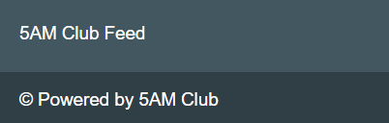

* **Code for this section is :-**

<footer>

        <p>5AM Club Feed</p>

    </footer>

<footer *class*="footsecond">

        <p>&copy; Powered by 5AM Club</p>

</footer>

**JS code used in this project**

const confirmPass = document.querySelector('#confirmpass');

const error = document.querySelector("#error")

confirmPass.addEventListener('input', (event) => {

    const pass = document.querySelector("#pass")

    if (pass.value != event.target.value) {

        error.innerText = "Password not matching."

    } else {

        error.innerText = ""

    }

});

const pass = document.querySelector('#pass');

pass.addEventListener('input', (event) => {

    const confirmPass = document.querySelector("#confirmpass")

    if (confirmPass.value != event.target.value) {

        error.innerText = "Password not matching."

    } else {

        error.innerText = ""

    }

});

**Python code used in this project**

from flask import Flask, request, render_template, redirect, url_for, flash, session

from flask_sqlalchemy import SQLAlchemy

app = Flask(__name__)

app.secret_key = 'aVerySecretKey'

app.config['SQLALCHEMY_DATABASE_URI'] = 'sqlite:///site.db'

app.config['SQLALCHEMY_TRACK_MODIFICATIONS'] = True

db = SQLAlchemy(app)

class UserData(db.Model):

    id = db.Column(db.Integer, primary_key=True)

    first_name = db.Column(db.String(32))

    last_name = db.Column(db.String(32))

    username = db.Column(db.String(128), unique=True, nullable=False)

    password = db.Column(db.String(128))

    dob = db.Column(db.String(20))

@app.route('/')

def index():

    if 'user' in session:

        return redirect(url_for('feed'))

    return render_template('index.html')

@app.route('/feed')

def feed():

    if 'user' in session:

        return render_template('feed.html', **session['user'])

    else:

        return redirect(url_for('login'))

@app.route('/login', methods=['POST', 'GET'])

def login():

    if request.method == 'GET': return redirect(url_for('index'))

    user = UserData.query.filter_by(username=str(request.form['username']), password=str(request.form['password'])).first()

    if user:

        session['user'] = {'username':user.username, 'password':user.password, 'first_name':user.first_name, 'last_name':user.last_name, 'dob':user.dob}

        return redirect(url_for('feed'))

    else:

        return redirect(url_for('index'))

@app.post('/signup')

def signup():

    user = UserData.query.filter_by(username=str(request.form['username'])).first()

    if user:

        return redirect(url_for('index'))

    data = {'first_name': request.form['first_name'],

            'last_name': request.form['last_name'],

            'username': request.form['username'],

            'password': request.form['password'],

            'dob': f"{request.form['mob']} {request.form['dayob']}, {request.form['yob']}"}

    user = UserData(**data)

    db.session.add(user)

    db.session.commit()

    session['user'] = data

    return redirect(url_for('feed'))

@app.get('/logout')

def logout():

    session.pop('user', None)

    return redirect(url_for('index'))

if __name__ == '__main__':

    app.run(debug=True)

**GitHub Links**

**GitHub Repository link:** [**https://github.com/AmanTheExecutable/SNS-Project**](https://github.com/AmanTheExecutable/SNS-Project)

[**https://github.com/voidknown04/SNS-Project**](https://github.com/voidknown04/SNS-Project)